MIPS Single Cycle Microprocessor Implementation Report

차 호 현(#32224560), outcider112@dankook.ac.kr  
Undergraduate Student in Mobile System Engineering, Dankook University

Code Repository: https://github.com /HOchacha/Computer-Architecture

**1. Introduction**

Computer Architecture is the fundamental theory of how the system constructed. Computer Architecture is the fundamental theory of how the system constructed. Computer Architecture is the fundamental theory of how the system constructed. Computer Architecture is the fundamental theory of how the system constructed. Computer Architecture is the fundamental theory of how the system constructed. Computer Architecture is the fundamental theory of how the system constructed. Computer Architecture is the fundamental theory of how the system constructed. Computer Architecture is the fundamental theory of how the system constructed.

(아래 그림에는 별도로, 시스템과 관련된 구조, 특히 ISA가 Interface 역할을 수행하고 있다는 것을 보여주면 좋을 것 같음)

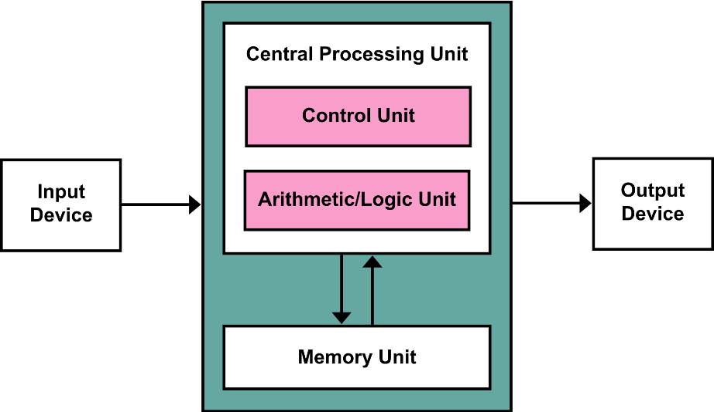

(ISA가 SW와 HW 간의 Interface 함에 따라서 우리가 어떠한 것을 준비해야 하는지에 대해서 작성)Computer Architecture is the fundamental theory of how the system constructed. Computer Architecture is the fundamental theory of how the system constructed. Computer Architecture is the fundamental theory of how the system constructed. Computer Architecture is the fundamental theory of how the system constructed. Computer Architecture is the fundamental theory of how the system constructed. Computer Architecture is the fundamental theory of how the system constructed. Computer Architecture is the fundamental theory of how the system constructed.

(모듈화 설계와, 간단한 테스트로 해당 구조를 검증하는데 성공할 수 있었다~에 대해서 작성할 것)Computer Architecture is the fundamental theory of how the system constructed. Computer Architecture is the fundamental theory of how the system constructed. Computer Architecture is the fundamental theory of how the system constructed. Computer Architecture is the fundamental theory of how the system constructed. Computer Architecture is the fundamental theory of how the system constructed. Computer Architecture is the fundamental theory of how the system constructed.

**2. Design Structure of a Single Cycle Program**

Computer Architecture is the fundamental theory of how the system constructed. Computer Architecture is the fundamental theory of how the system constructed. Computer Architecture is the fundamental theory of how the system constructed. Computer Architecture is the fundamental theory of how the system constructed. Computer Architecture is the fundamental theory of how the system constructed. Computer Architecture is the fundamental theory of how the system constructed. Computer Architecture is the fundamental theory of how the system constructed. Computer Architecture is the fundamental theory of how the system constructed.

(전반적인 구조에 대한 설명) Computer Architecture is the fundamental theory of how the system constructed. Computer Architecture is the fundamental theory of how the system constructed. Computer Architecture is the fundamental theory of how the system constructed. Computer Architecture is the fundamental theory of how the system constructed. Computer Architecture is the fundamental theory of how the system constructed. Computer Architecture is the fundamental theory of how the system constructed. Computer Architecture is the fundamental theory of how the system constructed.

(해당 구조에서, 특별히 추가한 나만의 Feature) Computer Architecture is the fundamental theory of how the system constructed. Computer Architecture is the fundamental theory of how the system constructed. Computer Architecture is the fundamental theory of how the system constructed. Computer Architecture is the fundamental theory of how the system constructed. Computer Architecture is the fundamental theory of how the system constructed. Computer Architecture is the fundamental theory of how the system constructed. Computer Architecture is the fundamental theory of how the system constructed. Computer Architecture is the fundamental theory of how the system constructed.

(현재 구현에서 지원하고 있는 명령어) Computer Architecture is the fundamental theory of how the system constructed. Computer Architecture is the fundamental theory of how the system constructed. Computer Architecture is the fundamental theory of how the system constructed. Computer Architecture is the fundamental theory of how the system constructed. Computer Architecture is the fundamental theory of how the system constructed. Computer Architecture is the fundamental theory of how the system constructed. Computer Architecture is the fundamental theory of how the system constructed. Computer Architecture is the fundamental theory of how the system constructed. Computer Architecture is the fundamental theory of how the system constructed.

**3. Implementation**

(프로그램 구조) Computer Architecture is the fundamental theory of how the system constructed. Computer Architecture is the fundamental theory of how the system constructed. Computer Architecture is the fundamental theory of how the system constructed. Computer Architecture is the fundamental theory of how the system constructed. Computer Architecture is the fundamental theory of how the system constructed. Computer Architecture is the fundamental theory of how the system constructed. Computer Architecture is the fundamental theory of how the system constructed. Computer Architecture is the fundamental theory of how the system constructed.

(모듈화 설계) Computer Architecture is the fundamental theory of how the system constructed. Computer Architecture is the fundamental theory of how the system constructed. Computer Architecture is the fundamental theory of how the system constructed. Computer Architecture is the fundamental theory of how the system constructed. Computer Architecture is the fundamental theory of how the system constructed. Computer Architecture is the fundamental theory of how the system constructed. Computer Architecture is the fundamental theory of how the system constructed.

(Control Logic에 대한 설명, Control Signal table에 대한 설명) Computer Architecture is the fundamental theory of how the system constructed. Computer Architecture is the fundamental theory of how the system constructed. Computer Architecture is the fundamental theory of how the system constructed. Computer Architecture is the fundamental theory of how the system constructed. Computer Architecture is the fundamental theory of how the system constructed. Computer Architecture is the fundamental theory of how the system constructed. Computer Architecture is the fundamental theory of how the system constructed.

|  |  |  |
| --- | --- | --- |
| Operator | Instruction Format | Operation |
| +, -, *, / | [OPCODE] [SOURCE] [TARGET]  [OPCODE] [SOURCE] [TARGET] | Arithmetic operation with source and target register. A result is stored in R0. During division operation, if the target register is set with Zero value, it triggers TRAP. |
| M | Move (Copy) the value of immediate value or register value. No result value made in this operation. |
| B |  |
| BEQ | If both source and R0 value are equal, jumps to specified address. The address is written in target. |
| GCD | Get the GCD value between source and target. If either source or target are not natural value, it triggers TRAP. |
| C | Set R0 as 1 if the source and target value are same. |
|  |  |

**4. Evaluation**

(테스트 프로그램 준비 과정)Computer Architecture is the fundamental theory of how the system constructed. Computer Architecture is the fundamental theory of how the system constructed. Computer Architecture is the fundamental theory of how the system constructed. Computer Architecture is the fundamental theory of how the system constructed. Computer Architecture is the fundamental theory of how the system constructed. Computer Architecture is the fundamental theory of how the system constructed. Computer Architecture is the fundamental theory of how the system constructed. Computer Architecture is the fundamental theory of how the system constructed.

(테스트 프로그램 소개)Computer Architecture is the fundamental theory of how the system constructed. Computer Architecture is the fundamental theory of how the system constructed. Computer Architecture is the fundamental theory of how the system constructed. Computer Architecture is the fundamental theory of how the system constructed. Computer Architecture is the fundamental theory of how the system constructed. Computer Architecture is the fundamental theory of how the system constructed. Computer Architecture is the fundamental theory of how the system constructed. Computer Architecture is the fundamental theory of how the system constructed. Computer Architecture is the fundamental theory of how the system constructed.

(각 테스트 프로그램 별, 결과 Formalizing)Computer Architecture is the fundamental theory of how the system constructed. Computer Architecture is the fundamental theory of how the system constructed. Computer Architecture is the fundamental theory of how the system constructed. Computer Architecture is the fundamental theory of how the system constructed. Computer Architecture is the fundamental theory of how the system constructed. Computer Architecture is the fundamental theory of how the system constructed. Computer Architecture is the fundamental theory of how the system constructed. Computer Architecture is the fundamental theory of how the system constructed.

(추가적으로 준비한 테스트 케이스)Computer Architecture is the fundamental theory of how the system constructed. Computer Architecture is the fundamental theory of how the system constructed. Computer Architecture is the fundamental theory of how the system constructed. Computer Architecture is the fundamental theory of how the system constructed. Computer Architecture is the fundamental theory of how the system constructed. Computer Architecture is the fundamental theory of how the system constructed. Computer Architecture is the fundamental theory of how the system constructed. Computer Architecture is the fundamental theory of how the system constructed.

**5. Conclusion**

**(여태까지 언급한 부분을 요약 및 작성, 여기에서 개선의 여지?)** Computer Architecture is the fundamental theory of how the system constructed. Computer Architecture is the fundamental theory of how the system constructed. Computer Architecture is the fundamental theory of how the system constructed. Computer Architecture is the fundamental theory of how the system constructed. Computer Architecture is the fundamental theory of how the system constructed. Computer Architecture is the fundamental theory of how the system constructed. Computer Architecture is the fundamental theory of how the system constructed.